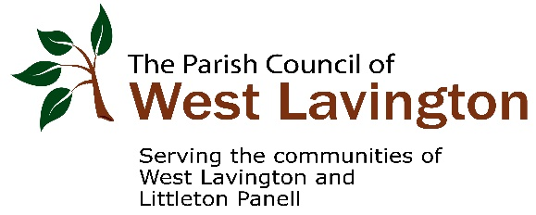

WEST LAVINGTON PARISH COUNCIL

COUNCIL MEMBERS

Mrs J Ford The Old Post Office, Church Street, West Lavington SN10 4LD CHAIR

Mr S Coxhead 11 Pagnell Lane, Littleton Panell SN10 4EW VICE CHAIR

Mr P Blundell 67 High Street, Littleton Panell SN10 4ES

Mrs H Freeman Ashdrew, 141 High Street, Littleton Panell SN10 4EU

Mr A Morton North Close, 61 High Street, Littleton Panell SN10 4ES

Mr D Muns The Bridge Inn, Church Street, West Lavington SN10 4LD

Mr R Oglesby 1 High Street, Littleton Panell SN10 4EL

Mr R Scott The Croft, Russell Mill Lane, Littleton Panell SN10 4ET

Ms L Gough 119 High Street, Littleton Panell, SN10 4EU

Clerk to the Parish Council
Kaye Elston
2 The Mercers
High Street
West Lavington
SN10 4BE clerk@westlavington.org.uk 07782 251464

THE PARISH COUNCIL MEETS AT 7.00pm ON THE FIRST THURSDAY OF EACH MONTH (EXCEPT AUGUST) IN THE VILLAGE HALL GILES ROOM. MEETINGS ARE HELD IN PUBLIC, AND YOU ARE WELCOME TO ATTEND.IF YOU WOULD LIKE TO SEE THE APPROVED MINUTES OF THE COUNCIL OR ITS COMMITTEES PLEASE VISIT OUR WEBSITE WWW.WESTLAVINGTON.ORG.UK , OR CONTACT THE CLERK TO THE COUNCIL.

10.09.20

